ID:N210264 NAME:Alapati.Sree Harsha
ROLL-NO:22
LAB -1 : VERIFICATION OF LOGIC GATES

List of logic gates:

The following are the commonly used basic logic gates:-

NAME | SYMBOL | IC-NO
AND | 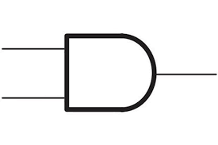 | 7408
OR | 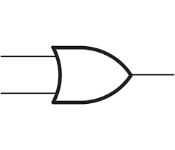 | 7432
NOT | 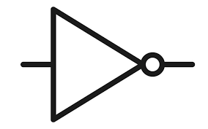 | 7404
NAND | 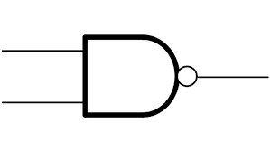 | 7400
NOR | 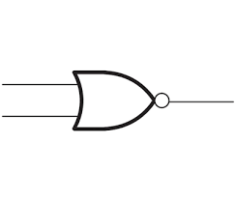 | 7402
XOR | 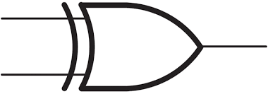 | 7486
XNOR | 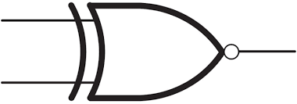 | 74266

AND GATE:

Description:-The AND Gate is a basic digital logic gate that performs the operation as defined by its name, i.e, if two inputs are to be 1 then output be 1 else output will be 0.

Circuit:-The circuit diagram for the gate is as follows:

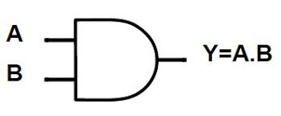
Truth Table:-The truth table represents the output of the gate for all possible input combinations

A | B | Y
0 | 0 | 0
0 | 1 | 0
1 | 0 | 0
1 | 1 | 1

Components Required:
- Multisim
- Probes
- Interactive Digital Constant
- IC 7408
- Power Supply
Multisim Circuit:
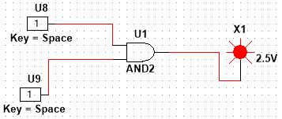

Procedure:
- Connect the Component on the multisim as per the circuit diagram
- Power the circuit and verify the functionality of the gate using the truth table
- Use the multisim to simulate and verify the result

OR GATE:

Description:-The OR Gate is a basic digital logic gate that performs the operation as defined by its name, i.e, if two inputs are to be 0 then output be 0 else output will be 1.

Circuit:-The circuit diagram for the gate is as follows:

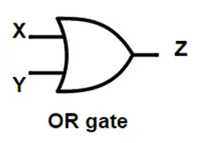
Truth Table:- The truth table represents the output of the gate for all possible input combinations

A | B | Z
0 | 0 | 0
0 | 1 | 1
1 | 0 | 1
1 | 1 | 1

Components Required:
- Multisim
- Probes
- Interactive Digital Constant
- IC 7432
- Power Supply

Multisim Circuit:
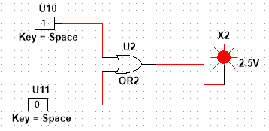
Procedure:
- Connect the Component on the multisim as per the circuit diagram
- Power the circuit and verify the functionality of the gate using the truth table
- Use the multisim to simulate and verify the result

NOT GATE:

Description:-The NOT Gate is a basic digital logic gate that performs the operation as defined by its name, i.e, if two input is to be 1 then output be 0 else output will be 1.

Circuit:-The circuit diagram for the gate is as follows:
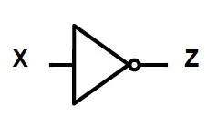

Truth Table:-

X | Z
0 | 1
1 | 0

Components Required:
- Multisim
- Probes
- Interactive Digital Constant
- IC 7404
- Power Supply

Multisim Circuit:
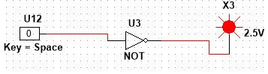

Procedure:
- Connect the Component on the multisim as per the circuit diagram
- Power the circuit and verify the functionality of the gate using the truth table
- Use the multisim to simulate and verify the result

NAND GATE:

Description:-The NAND Gate is a basic digital logic gate that performs the operation as defined by its name, i.e, it is opposite to the AND Gate

Circuit:-The circuit diagram for the gate is as follows:
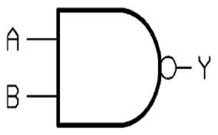

Truth Table:- The truth table represents the output of the gate for all possible input combinations

A | B | Y
0 | 0 | 1
0 | 1 | 1
1 | 0 | 1
1 | 1 | 0

Components Required:
- Multisim
- Probes
- Interactive Digital Constant
- IC 7400
- Power Supply

Multisim Circuit:
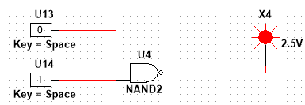
Procedure:
- Connect the Component on the multisim as per the circuit diagram
- Power the circuit and verify the functionality of the gate using the truth table
- Use the multisim to simulate and verify the result

NOR GATE:

Description:-The NOR Gate is a basic digital logic gate that performs the operation as defined by its name, i.e, it is opposite to the OR Gate

Circuit:-The circuit diagram for the gate is as follows:
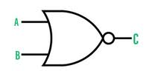

Truth Table:- The truth table represents the output of the gate for all possible input combinations

A | B | C
0 | 0 | 1
0 | 1 | 0
1 | 0 | 0
1 | 1 | 0

Components Required:
- Multisim
- Probes
- Interactive Digital Constant
- IC 7402
- Power Supply

Multisim Circuit:
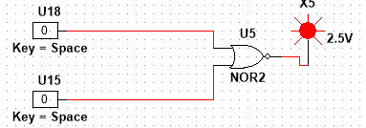
Procedure:
- Connect the Component on the multisim as per the circuit diagram
- Power the circuit and verify the functionality of the gate using the truth table
- Use the multisim to simulate and verify the result

XOR GATE:

Description:-The XOR Gate is a basic digital logic gate that performs the operation as defined by its name, i.e, If inputs are different then output will be 1
Else output will be 0.

Circuit:-The circuit diagram for the gate is as follows:
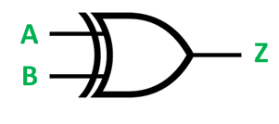
Truth Table:- The truth table represents the output of the gate for all possible input combinations

A | B | Z
0 | 0 | 0
0 | 1 | 1
1 | 0 | 1
1 | 1 | 0

Components Required:
- Multisim
- Probes
- Interactive Digital Constant
- IC 7486
- Power Supply

Multisim Circuit:
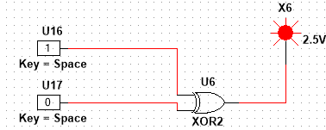
Procedure:
- Connect the Component on the multisim as per the circuit diagram
- Power the circuit and verify the functionality of the gate using the truth table
- Use the multisim to simulate and verify the result

XNOR GATE:

Description:-The XNOR Gate is a basic digital logic gate that performs the operation as defined by its name, i.e, it is opposite to XOR gate

Circuit:-The circuit diagram for the gate is as follows:
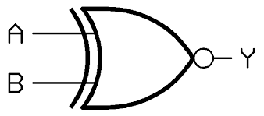
Truth Table:- The truth table represents the output of the gate for all possible input combinations

A | B | Y
0 | 0 | 1
0 | 1 | 0
1 | 0 | 0
1 | 1 | 1

Components Required:
- Multisim
- Probes
- Interactive Digital Constant
- IC 74266
- Power Supply

Multisim Circuit:
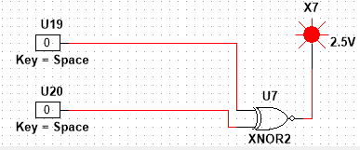
Procedure:
- Connect the Component on the multisim as per the circuit diagram
- Power the circuit and verify the functionality of the gate using the truth table
- Use the multisim to simulate and verify the result

